***Report On***

**WATER LEVEL CONTROLLER USING 555 TIMER**

**Introduction**

555 timer-based automatic water level controller circuits which will automatically switch ON and OFF of the domestic water pump set based on the water level of the tank. 555 timer is used to control the water pump based on the tank water level. This circuit uses two water level sensors one is fixed at the bottom of the tank and the other one is placed at the top of the tank.

In this project, the Schematic design & PCB Layout for the circuit that will automatically control the water pump based on the water level using 555 Timer is designed.

* It should switch off the water pump if the water level is more.
* It should switch on the water pump if the water level is less.

**LM 555 Timer**

The 555 Timer is a commonly used IC designed to produce a variety of output waveforms with the addition of an external RC network.

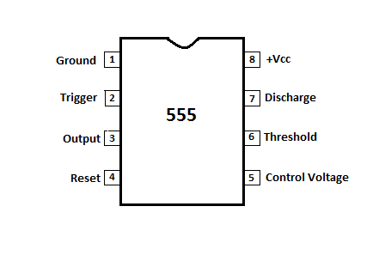

**Circuit Description**

This automatic water level controller circuit ensures that the tank always has a sufficient amount of water. There are many houses or buildings that, due to their geographical location, do not have the necessary water pressure.In order for the pressure to increase and be able to reach everywhere, it is necessary to place an elevated tank and thus the water is distributed by gravity.

To bring the water from the ground level to the tank, a pump (motor) is used. This pump activates itself whenever the water level is below an already set level and deactivates when it reaches a maximum level, also set.The tank has 3 sensors that indicate the amount of water in the tank to the controller circuit.

When the tank is low or has no water, no sensor touches the liquid or only the lower sensor does. In this case the pump is connected and pumping water to the elevated tank. See that the pump is working (its normal state) when the relay is not active.

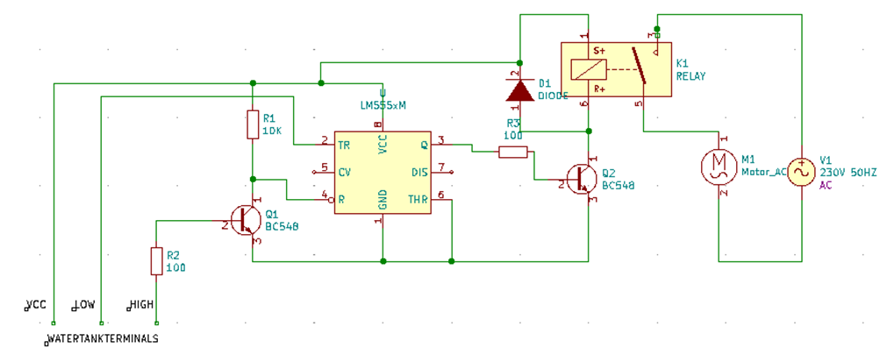

**Operation**

***When the water level rises:***

In this case, the 555 outputs a high voltage level (approximately 10 to 11 volts) that, after passing through the network of capacitors, diode and resistance, does not saturate the transistors.When the water reaches the level of the second sensor, there is no change and the pump is still active filling the tank.When the water reaches the level of the third sensor (the upper sensor), the 555 integrated circuit starts its operation as an astable multivibrator. This multivibrator delivers a continuous square wave at its output, which is rectified (half-wave rectification) and applied to the set of two cascaded transistors.These transistors go into saturation and activate the relay, which in turn disconnects the water pump, ceasing to fill the tank.

### *When the water level drops:*

The water level drops when water consumption starts.When the three sensors are still underwater (tank full), the relay is active and the pump is not connected (it does not pump water into the tank). When the upper sensor is no longer underwater, the relay is still active and the pump still does not work (it does not pump water into the tank). When the second sensor is no longer underwater, the relay is deactivated and the pump is switched on (water is pumped into the tank). Thus, the process of filling and emptying the water is constantly repeated.

**Conclusion**

In this project, Schematic design & PCB Layout for the circuit of the project automatically controls the water pump based on the water level using 555 Timer. The system switches OFF the water pump if the water level is more. It also switches ON the water pump if the water level is less.